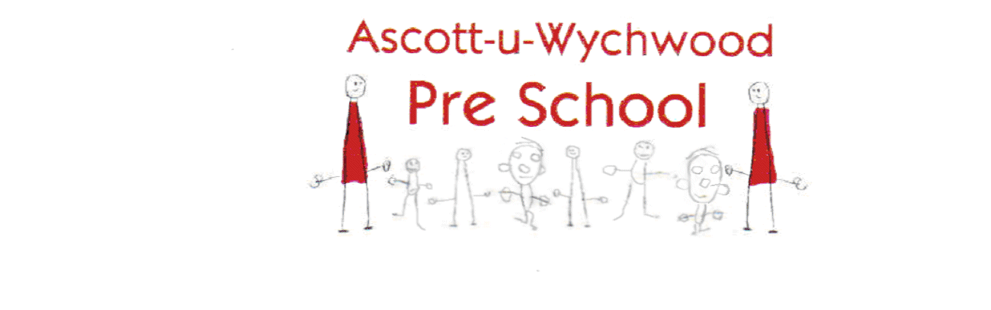
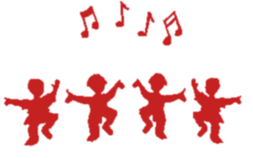
s

Term 2 Themes

“Bonfire Night” Wednesday 6th November

“Numbers & Letters” Wednesday 13th November

“Films” Wednesday 20th November

“Nursery Rhymes” Wednesday 27th November

“Ballroom Dancing” Wednesday 4th December

“The Jungle” Wednesday 11th December

“Christmas” Wednesday 18th December

