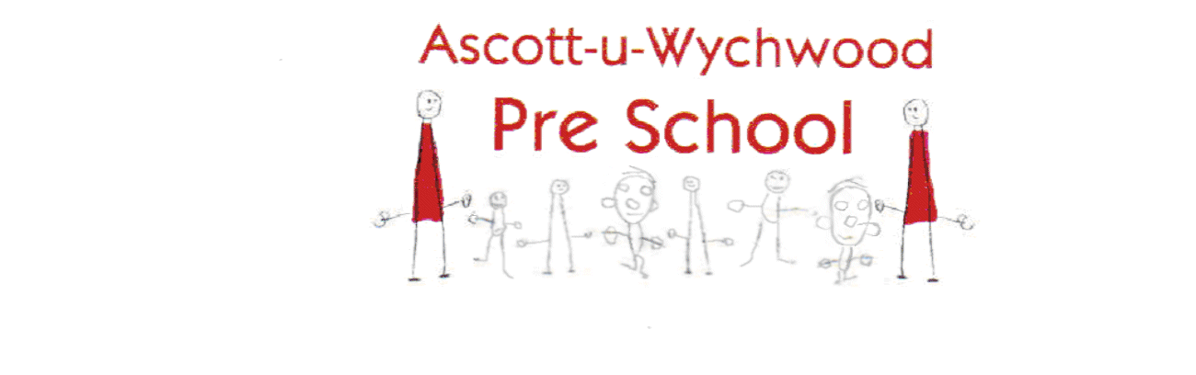
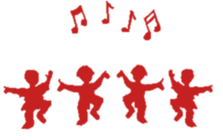
s

Term 1 2023

Themes

“Colours” Friday 8th September

“Animals” Friday 15th September

“Kings and Queens” Friday 22nd September

“Transport” Friday 29th September

“Building” Friday 6th October

“Tap Dancing” Friday 13th October

“Disco” Friday 20th October

